**Comsats University Islamabad, Lahore Campus**

**Course Title: Object Oriented Programming**

**Assignment #4**

**Submitted by: Attika Hussain (SP24-BSE-017)**

**Fatima Chaudhry (SP24-BSE-024)**

**Uswa Maryam (SP24-BSE-121)**

**Section: A**

**Submitted to: Sir Shahid Bhatti**

**Assigned On: 6th December 2024**

**Submission Date: 20th December 2024**

**Fruit Catcher Game**

* This is the login page of the Fruit Catcher Game

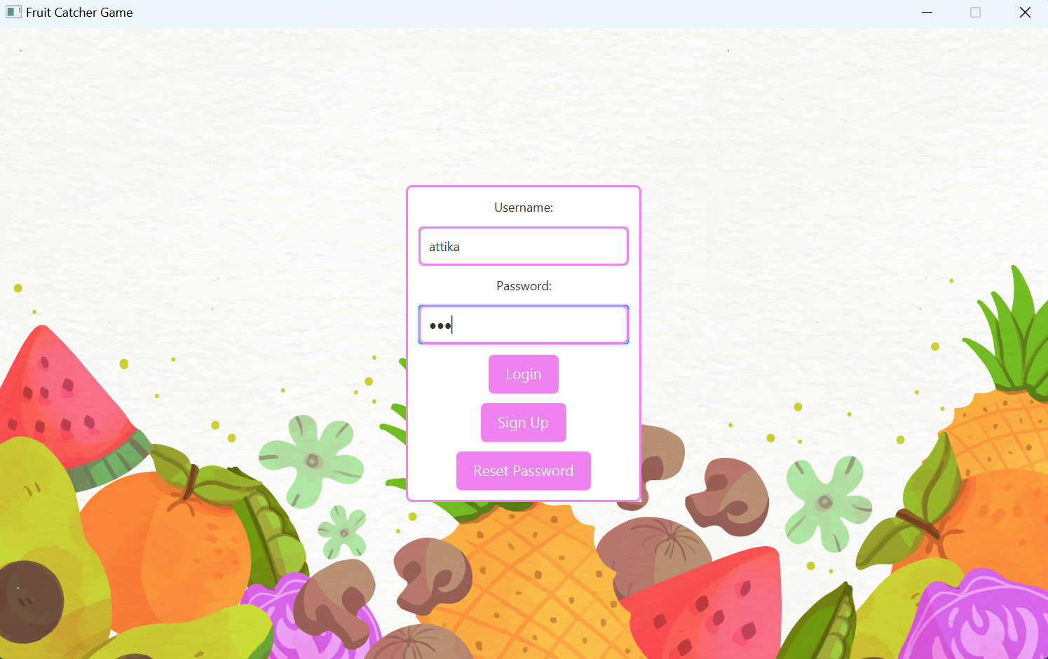

* After logging in the screen for level selection appears.

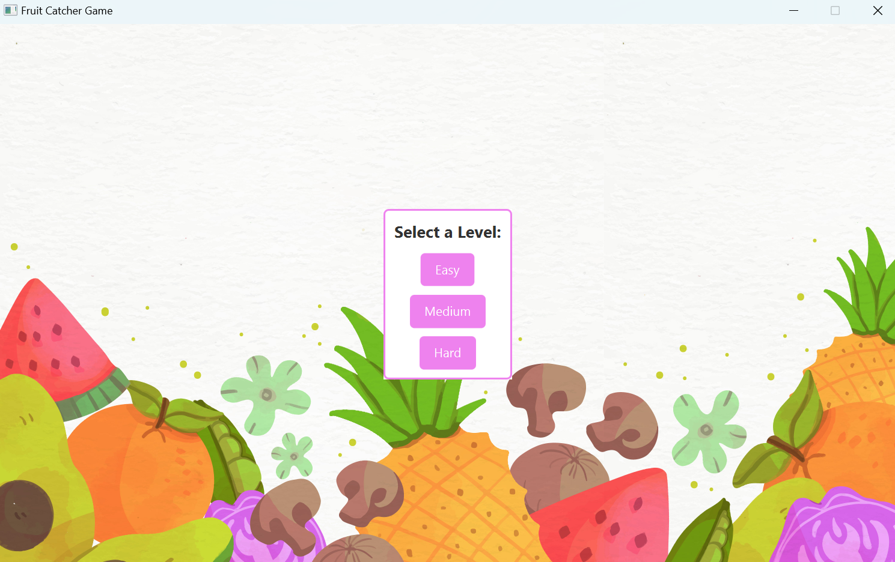

* Easy Level has a target to score 10 fruits in 30 seconds.

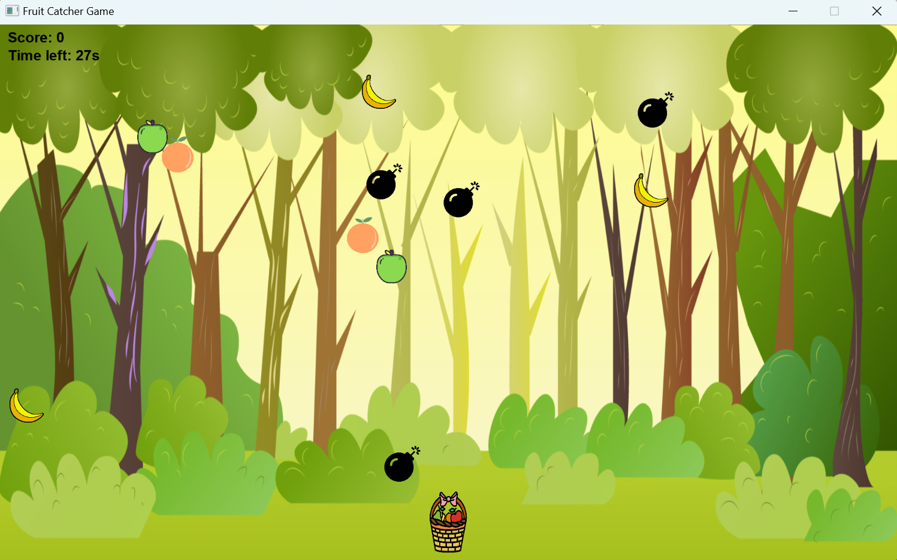

* Medium Level has to score 15 fruits in 20 seconds.

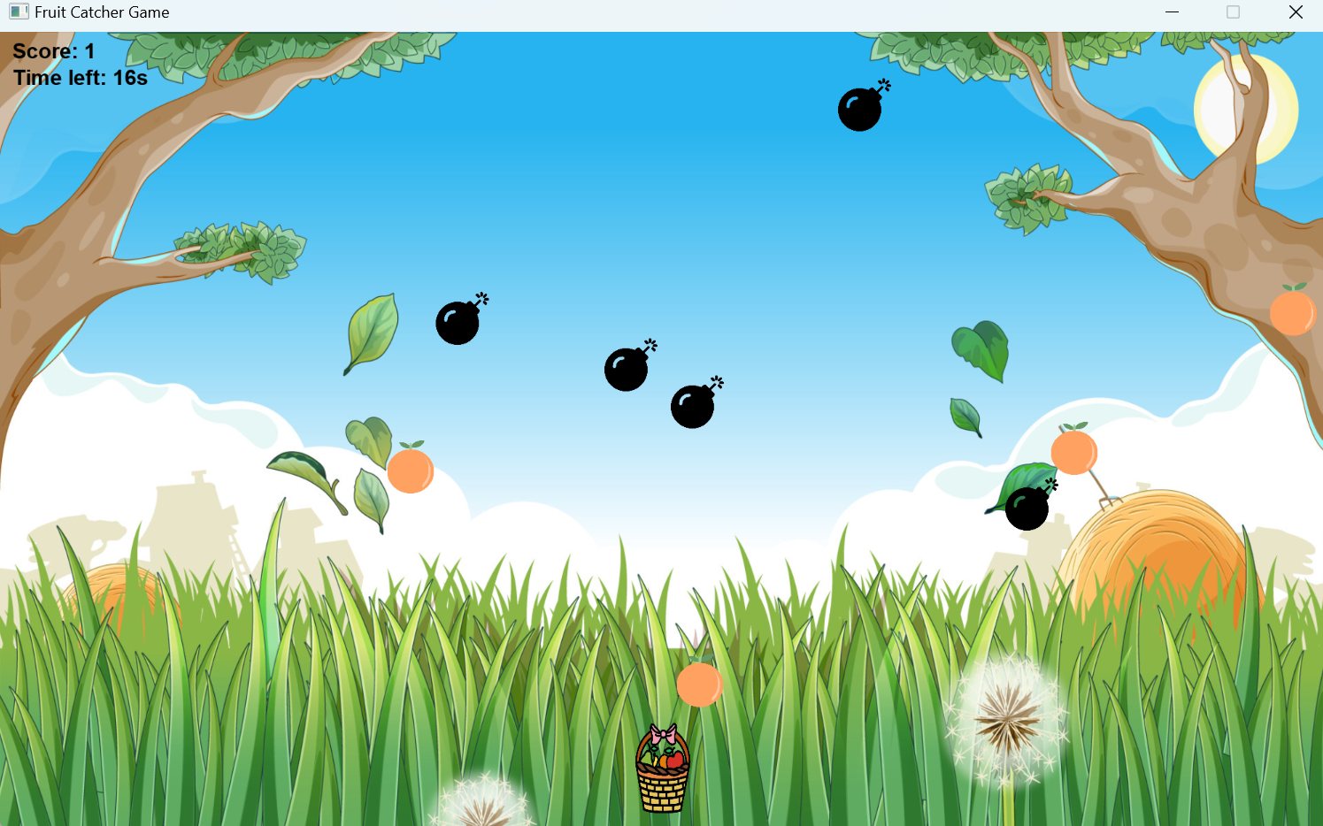

* The Hard level has to score 20 in 15 seconds.

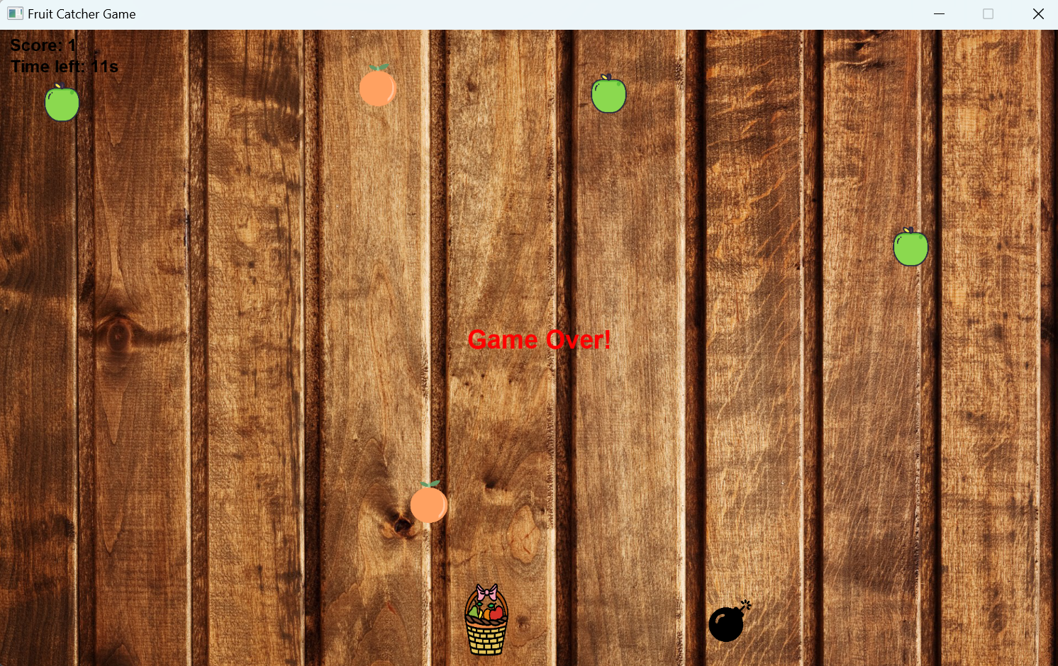

* After user wins or loses, the user is redirected to the level screen.